PLATES, DIES AND OTHER PREPARATION COSTS

There are a few N-K-1 parameters that are used for complete use of preparation costs such as plates, dies, film, artwork, etc.

N-K-1 ADDPREP Generally will force creation a plate or die code directly into the prep file.
N-K-1 OEPREP Logical value will erase the prep charge from the estimate once invoiced.
N-K-1 CEPREP Provides logic to round up the prep charge on the quote.
N-K-1 JOBCREAT Decimal Value dictates if billable prep costs are transferred to the job file.
N-K DIEFILE To house Folder for Lookup on Die# on Spec Folder
N-K CADFILE To house Folder for Lookup on Cad# on Spec Folder
E-R-7 Prep List by Material Type shows dies and plates by estimate / order.
E-R-4 Prep List shows all prep codes in the Prep / Die File.

In general, all plates and dies should be stored in the prep and die file. The preparation files may be added directly to this file via the ADD button or they may be added automatically when the die number or plate number is added to the SPEC folder of an estimate. Set the logical value to YES in the control parameter called AddPrep and then most information will transfer automatically from the estimate. Once the plate or die number are added to the estimate, the prep report will show the estimate number, order number and last time this material was ordered or updated. Since this report may be sorted by salesman, this is useful to clear up your die rack locations.

The SPEC folder and PREP / ROUTING folder may use different preparation codes, however the PREP folder is the folder that houses the cost and markup percentage that transfers to the quote as well as the order entry MISC folder. The SPEC folder may have a plate number such as P123, however a generic code such as PLATE may be added to the Prep folder, which is just used for cost and sell price. Please note, the P123 number may be added to the Prep folder to keep the same number. The binoculars on the SPEC folder may be used to

N-K DIEFILE To house Folder for Lookup on Die# on Spec Folder

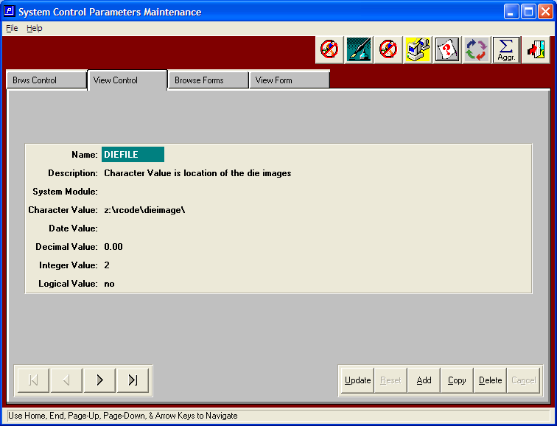

N-K DIEFILE To House Folder for Lookup on Die# on Spec Folder
Binocular Icon next to the Die#. This will Browse Microsoft Explorer starting with the folder defined under N-K-1 DIEFILE character value whereby the customer can enter the Disk Drive and folder to search for the Die numbers on their system. New Die button will be a Box Design to preview the die image. Once selected, the .JPG file will transfer to the DIE IMAGE folder. The Existing F1 on the Die# currently searches the Prep File and this will remain the same logic.
Hence the binocular will search the image file and F1 will search the Prep File.

When clicking the Binoculars on the Die File in the estimate SPEC folder, the default may be either a .PDF, .JPG or .Bmt.
Integer value = 0 will default to .Jpg
Integer value = 1 will default to .Bmt
Integer value = 2 will default to .Pdf
N-K-1 ADDPREP Generally will force creation a plate or die code directly into the prep file.

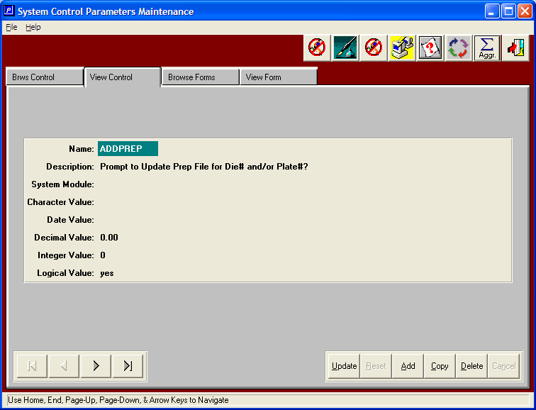

ADD PREP? Logical Value = YES forces the Die# and Plate# to be added to the PREP file when added to the SPEC folder in estimating. When a Die# or Plate# is added to the spec folder, if the new number does not exist in the prep file, then the system will prompt
“Die# or Plate# does not exist” Update Prep File? YES will then create the record in the prep file and display the file for updating. The program will download current estimating information such as customer code, estimate number, number up, style, length, width, depth, etc. The owner information will default to your Company Name as defined in the customer file with the type of X and the ownership percentage will be 100%. Information such as Category, Cost, GL Account# and Bin Location that is not contained in the estimate will transfer from the first prep material by prep material type. For example, the Plate GL Account # will default from the first plate material. Likewise, the Die GL Account # will default from the first Die material. Once the data is downloaded the new prep code will be in UPDATE mode so that the estimator may make any changes before saving the data. Once saved, the system will return to the estimate. Logical Value = No, will not force creation of the plate or die code in the prep file.

N-K-1 CEPREP Provides logic to round up the prep charge on the quote.

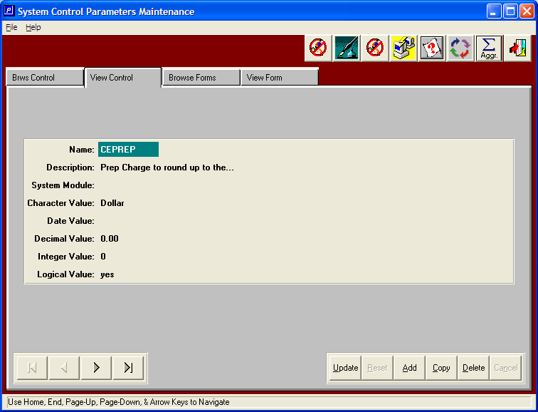

N-K CEPREP New Option to Round Up Billable Prep Charges

Character Value options are Penny and Dollar. To round up the billable charge for prep material to the nearest dollar or penny. Set this to Penny and the estimate will calculate to the penny. If the flag is set to Dollar, then the estimate charge and the quote would no show only dollars.
N-K-1 OEPREP Logical value will erase the prep charge from the estimate once invoiced.

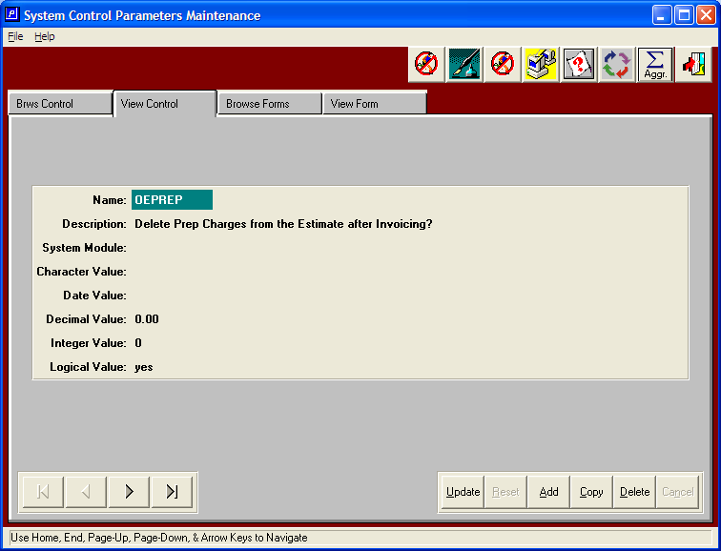

OEPREP: New option to delete Prep Changes from the Estimate.

Logical Value = YES, the prep charges will be deleted. If the logical value is NO, then the prep charges will be changed to "N"o Charge from "B"illable. Please note, the amoritization percentage must be 100%, otherwise, the prep code will remain for future billing.

When the simon code is an "S", after the first order has been billed for the line item pertaining to that forms prep charge, the prep charges will be deleted from the estimate. . Please note, if the prep charges are billed by Form#, then the prep charge would be deleted based on the FG item that was billed. Therefore, if the first item was billed, then only the plate charge for that item/form should be billed, hence only that prep item should be deleted from the estimate.

N-K-1 JOBCREAT Decimal Value dictates if billable prep costs are transferred to the job file.

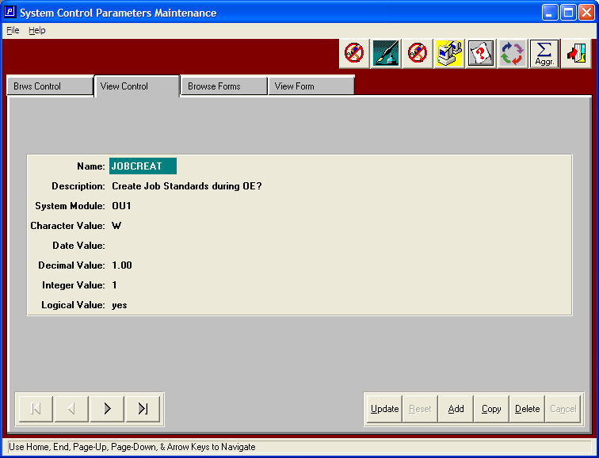

JOBCREAT - Create Job Standards during OE?

Decimal = 0 currently does not move the costs from estimating to the job file, if the costs are billed separately.. Decimal value = 1 the Misc Materials and Prep costs that are billed separately would also be listed on the job file.

Logical Value = Yes, then jobs will automatically be created when orders are added from estimates. All materials, dies, preparation, and machine routing will be downloaded to the job file so that the job ticket prints data from the job file. Once the job is created, the job status will change to an R for Released. If the logical value is set to NO, the job standards must be manually created through the job cost module, therefore the job status would remain as P for Pending until released.

